Closed loop op-amp configuration
The op-amp can be effectively utilized in linear applications by providing a feedback from the output to the input, either directly or through another network. If the signal feedback is out- of-phase by 180 with respect to the input, then the feedback is referred to as negative feedback or degenerative feedback. Conversely, if the feedback signal is in phase with that at the input, then the feedback is referred to as positive feedback or regenerative feedback.
An op – amp that uses feedback is called a closed – loop amplifier. The most commonly used closed – loop amplifier configurations are 1. Inverting amplifier (Voltage shunt amplifier) 2. Non- Inverting amplifier (Voltage – series Amplifier)

Inverting Operational Amplifier Configuration
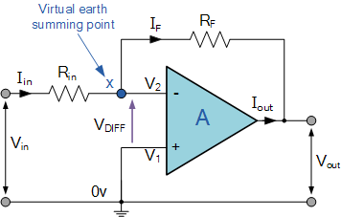
In this Inverting Amplifier circuit the operational amplifier is connected with feedback to produce a closed loop operation. When dealing with operational amplifiers there are two very important rules to remember about inverting amplifiers, these are: “No current flows into the input terminal” and that “V1 always equals V2”. However, in real world op-amp circuits both of these rules are slightly broken.
This is because the junction of the input and feedback signal ( X ) is at the same potential as the positive ( + ) input which is at zero volts or ground then, the junction is a “Virtual Earth”. Because of this virtual earth node the input resistance of the amplifier is equal to the value of the input resistor, Rin and the closed loop gain of the inverting amplifier can be set by the ratio of the two external resistors.
We said above that there are two very important rules to remember about Inverting Amplifiers or any operational amplifier for that matter and these are.
- No Current Flows into the Input Terminals
- The Differential Input Voltage is Zero as V1 = V2 = 0 (Virtual Earth)
Then by using these two rules we can derive the equation for calculating the closed-loop gain of an inverting amplifier, using first principles.
Current ( i ) flows through the resistor network as shown.
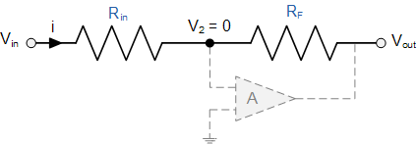
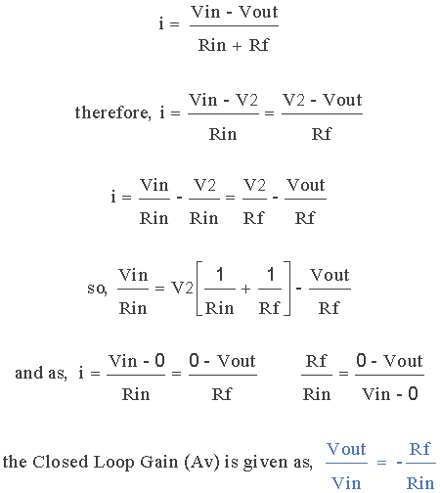
Then, the Closed-Loop Voltage Gain of an Inverting Amplifier is given as.
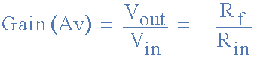
and this can be transposed to give Vout as:
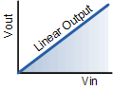
Linear Output
The negative sign in the equation indicates an inversion of the output signal with respect to the input as it is 180º out of phase. This is due to the feedback being negative in value.
The equation for the output voltage Vout also shows that the circuit is linear in nature for a fixed amplifier gain as Vout = Vin x Gain. This property can be very useful for converting a smaller sensor signal to a much larger voltage.

Non-inverting Operational Amplifier Configuration
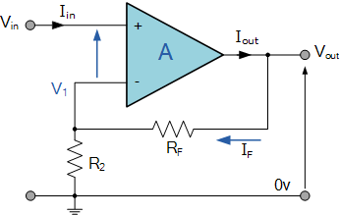
In the previous Inverting Amplifier, we said that for an ideal op-amp “No current flows into the input terminal” of the amplifier and that “V1 always equals V2”. This was because the junction of the input and feedback signal ( V1 ) are at the same potential.
In other words the junction is a “virtual earth” summing point. Because of this virtual earth node the resistors, Rƒ and R2 form a simple potential divider network across the non-inverting amplifier with the voltage gain of the circuit being determined by the ratios of R2 and Rƒ as shown below.

Equivalent Potential Divider Network
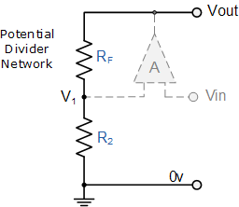
Then using the formula to calculate the output voltage of a potential divider network, we can calculate the closed-loop voltage gain ( A_{V} ) of the Non-inverting Amplifier as follows:
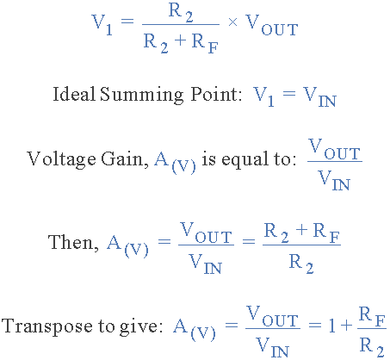
Then the closed loop voltage gain of a Non-inverting Operational Amplifier will be given as:
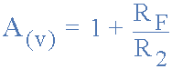
We can see from the equation above, that the overall closed-loop gain of a non-inverting amplifier will always be greater but never less than one (unity), it is positive in nature and is determined by the ratio of the values of Rƒ and R2.
If the value of the feedback resistor Rƒ is zero, the gain of the amplifier will be exactly equal to one (unity). If resistor R2 is zero the gain will approach infinity, but in practice it will be limited to the operational amplifiers open-loop differential gain, ( A_{O} ).
We can easily convert an inverting operational amplifier configuration into a non-inverting amplifier configuration by simply changing the input connections as shown.
